5G RAN Automation Using AI

INTRODUCTION:
5G networks are handling more users and higher data traffic than previous generations. Because of this, managing the network manually is becoming difficult. In 5G RAN, many factors like bandwidth, signal strength, and power affect the network performance. To improve efficiency and reduce manual work, Artificial Intelligence can be used to analyze network data and help in making better decisions automatically.
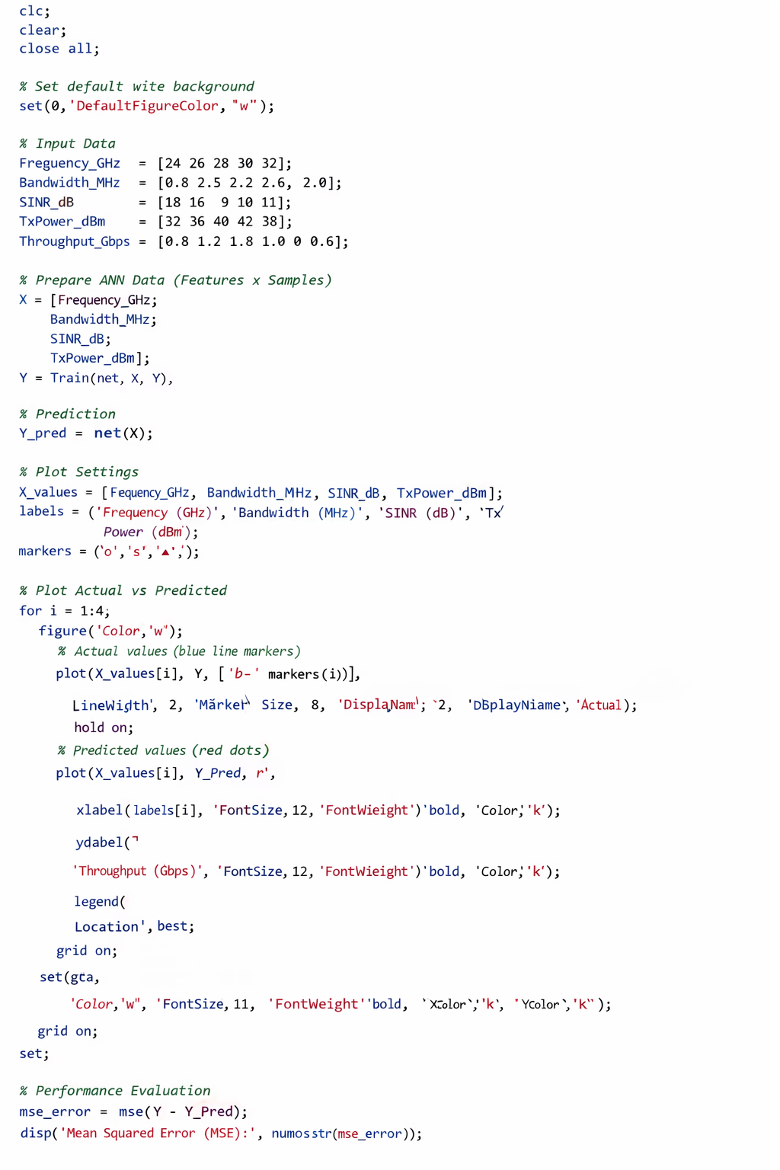
Algorithm:

Training Data Table:
Frequency (GHz) | Bandwidth (MHz) | SINR (dB) | Tx Power (dBm) | Throughput (Gbps)
24 | 0.8 | 18 | 32 | 0.8
26 | 2.5 | 16 | 36 | 1.2
28 | 3.2 | 9 | 40 | 1.8
30 | 2.6 | 10 | 42 | 1.0
32 | 2.0 | 11 | 38 | 0.6
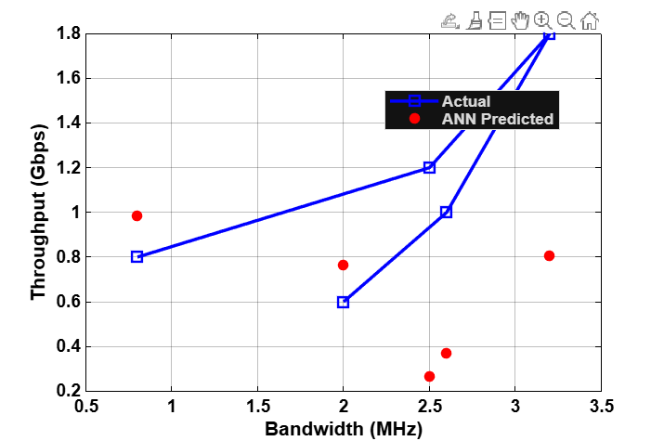
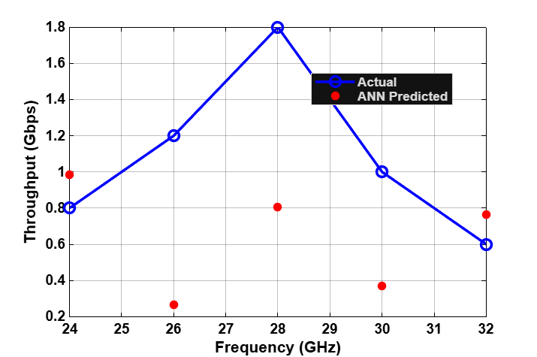
Plots:

